N_{re} vs f would be found for each type of roughness. Experiments on artificially roughened pipe have confirmed these expectations. It has also been found that all clean, new commercial pipe seem to have the same type of roughness and that each material of construction has its own characteristic roughness parameter.
K
K
Figure 2.11. Idealized Hydraulically smooth pipes
Old, foul and corroded pipe can be very rough, and the character of the roughness differs from that of clean pipe. Roughness has no appreciable effect on the friction factor for laminar flow unless k is so large that the measurement of the diameter becomes uncertain.
Material | Surface Roughness k, inch
Drawn tubing | 0.00006
Commercial steel | 0.0018
Galvanized iron | 0.006
Cast iron | 0.010
Wood stave | 0.0072 - 0.036
Concrete | 0.012 - 0.12
Riveted steel | 0.036 - 0.36

Friction factor chart
For design purposes, the frictional characteristics of round pipe, both smooth and rough are summarized by friction factor chart which is a plot of log f vs log N_{re} . For laminar flow the f vs N_{re} relation is f =16/N_{re}. A log-log plot of the above equation is straight line with a slope of -1. This plot line is shown in figure 2.12 for Reynolds number less than 2100.
For turbulent flow the lowest line represents the friction factor for smooth tube. The other curved lines in the turbulent flow range represents the friction factors for various types of commercial pipe, each of which is characterized by a different value of k.

The use of friction factor chart:
If the rate of flow, the density and viscosity of fluid and the diameter of the pipe are known, the Reynolds number is calculated. The Reynolds number is used as the abscissa, the friction factor is read as the ordinate and is used to calculate the desired friction loss or wall shear. The friction loss so calculated, combined with other forms of friction within the flow system, may then be substituted for h_{f} in the Bernoulli’s equation.
Calculation of flow rate from know skin friction
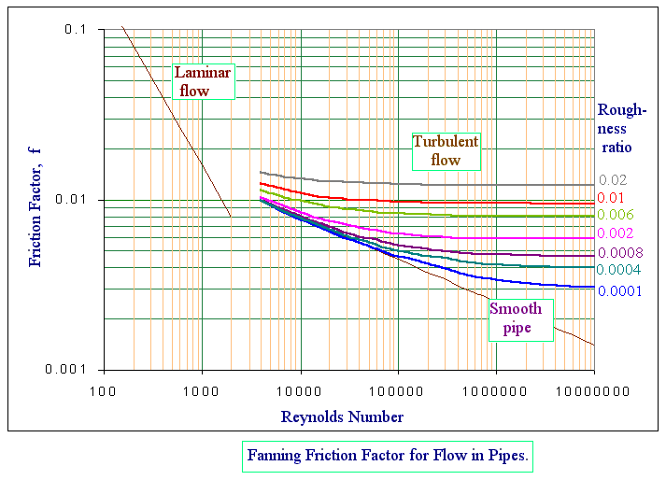
Figure 2.12. Friction – Factor Chart
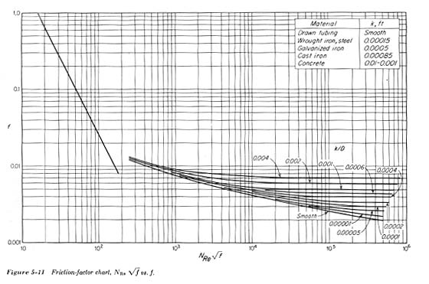
Figure 2.13. Friction-factor chart, N_{re√}f vs. f.
Friction factor chart is useful for calculating h_{fs} from a known pipe size and conditions of flow. It is not convenient for the calculation of the flowrate from a known h_{fs}, because ū, the average linear velocity, appears in both N_{re} and f. A trail and error solution can be used for this calculation, but a more convenient solution can be obtained by plotting N_{re}√f as abscissa and f as ordinate.
N_{re} √f = 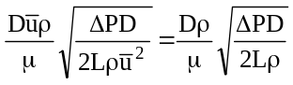
To use figure 2.13, the abscissa is calculated from the known frictional loss (i.e., pressure loss), the ordinate f is read, and the velocity ū is calculated from f by means of equation 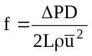
Friction factor in flow through channels of non circular cross section
The friction in long straight channels of constant non circular cross section can be estimated by using the equations for circular pipe, if the diameter in Reynolds number and in the definition of the friction factor is taken as an equivalent diameter, defined as four times the hydraulic radius. The hydraulic radius is denoted by r_{H} and in turn is defined as the ratio of the cross sectional area of the channel to the wetted perimeter (perimeter of the channel in contact with fluid) of the channel.
i. For circular pipes :
D
r_{H} =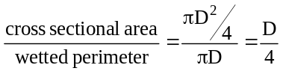
The equivalent diameter = 4* r_{H} = 4*D/4 = D

ii. for Annulus
D₂
D₁
r_{H} =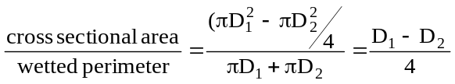
The equivalent diameter = 4* r_{H} = 4*(D₁ – D₂)/4 = D₁ – D₂
a
iii. For square with side ‘a’
r_{H} =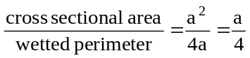
The equivalent diameter = 4* r_{H} = 4*a/4 = a
iv. For a rectangle with length l and breadth b
r_{H} =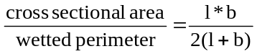
b
l
The equivalent diameter = 4* r_{H}
D_{eq}=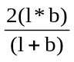
v. For a equilateral triangle
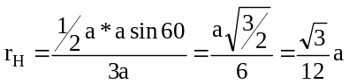
a
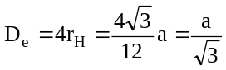

Flow through pipes
Pipes in series :
D₁
D₂
D₃
Q
Q
u₁
u₂
u₃
Q is the same in all the pipes (continuity equation)
i.e. u₁ S₁ = u₂ S₂ = u₃ S₃ = Q
so total h_{f} = h_{f1} + h_{f2} + h_{f3}
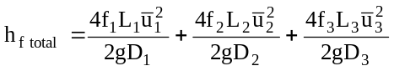
pipes in parallel :
Q
Q
Q₁
Q₂

Here Q = Q₁+Q₂
Hence h_{f} = h₁ = h_{f2}
Minor Energy Loses
The loss of head or energy due to friction in a pipe is known as major loss. While the loss of energy due to direction is called minor loss of energy. The minor loss of energy (or head) includes the following cases
- loss of head due to sudden enlargement
- loss of head due to sudden contraction
- loss of head at the entrance to a pipe
- loss of head at the exit of a pipe
- loss of head due to an obstruction in a pipe
- loss of head in various pipe fittings.
In case of of a long pipe (L/D >1000) the above losses are small as compared with the loss of head due to friction and hence they are called minor losses and even may be neglected without serious error. But in case of a short pipe (L/D<1000), these losses are comparable with the loss of head due to friction.

Friction loss from sudden expansion of cross section
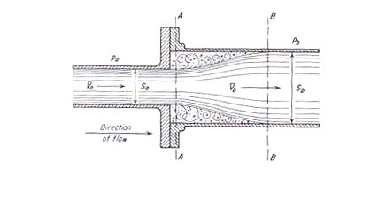
If the cross section of the conduit is suddenly enlarged, the fluid stream separates from the wall and issues as a jet into the enlarged section. The jet then expands to fill the entire cross section of the larger conduit. The space between the expanding jet and the conduit wall is filled with fluid in vortex motion characteristic of boundary layer separation, and considerable friction is generated with in this space. This effect is shown in figure 2.14.
Figure 2.14 Flow at sudden enlargement of cross section

The friction loss h_{fe} from a sudden expansion of cross section is proportional to the velocity head of the fluid and can be written as 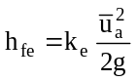, where k_{e} is a proportionality factor called expansion loss coefficient and is given by an empherical equation 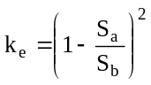and ū_{a} is the average velocity of the upstream.
Friction loss from sudden contraction of cross section
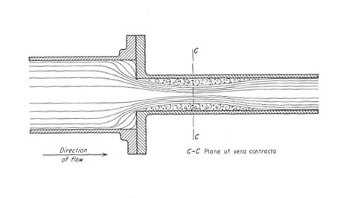
When the cross section of the conduit is suddenly reduced, the fluid stream cannot flow around the sharp corner and the stream breaks contact with the wall of the conduit. A jet is formed, which flows into the stagnant fluid in the smaller section. The jet first contracts and then expands to fill the smaller cross section, and down stream from the point of contraction the normal velocity distribution eventually is established. The cross section of minimum area at which the jet changes from contraction to an expansion is called vena-contracta. The flow pattern of a sudden contraction is shown in figure 2.15.
Figure 2.14 Flow at sudden contraction of cross section

The friction loss from sudden contraction is proportional to the velocity head and can be calculated by the equation 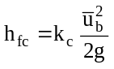, where ū_{b} is average velocity in the downstream.
For laminar flow k_{c}<0.1 and the contraction loss h_{fc} is negligible.
For turbulent flow k_{c} is given by an empherical equation 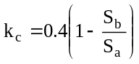
Head loss due to pipe fittings and valves
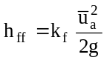, where k_{f} is loss factor for fitting
ū_{a} average velocity in pipe leading to the fitting
Head loss at the entrance of a pipe
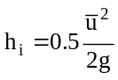
Head loss at the exit of a pipe
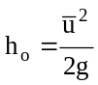
Fitting | Loss Coefficient, K
Gate valve (open to 75% shut) | 0.25 - 25
Globe valve | 10
Pump foot valve | 1.5
Return bend | 2.2
90º elbow | 0.9
45º elbow | 0.4
Large-radius 90º bend | 0.6
Tee junction | 1.8
Sharp pipe entry | 0.5
Radiused pipe entry | 0

Worked Examples
2.30. Water flows at 7.2m³/hr through a sudden enlargement from a 40mm to a 50mm diameter pipe. What is the loss in head.
Data: Q = 7.2 m³/hr = 7.2/3600 = 0.002m³/s
D_{a}=40mm = 0.04m | D_{b}=50mm = 0.05m
S_{a} = (π/4)* 0.04² = 1.26*10⁻³m² | S_{b} = (π/4)* 0.05² = 1.96*10⁻³m²
We know Q=u_{a}S_{a} ⇒ u_{a}=Q/S_{a}
u_{a} = 0.002/1.26*10⁻³ = 1.587m/s
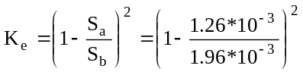=0.12755
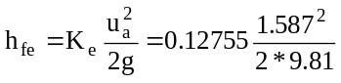=0.1637 m
h_{fe} = 0.01637*9.81 = 0.161 J/kg

2.31. Calculate head loss when water is flowing though a pipe of 2 cm at the rate of 0.754 lit/min is suddenly sent to a pipe of 4 cm diameter.
Data: Q = 0.754 lit/min = 0.754*10⁻³/60 = 1.256*10⁻⁵m³/s
D_{a}=2cm = 0.02m | D_{b}=4cm = 0.04m
S_{a} = (π/4)* 0.02² =0.3142*10⁻³m² | S_{b} = (π/4)* 0.04² = 1.26*10⁻³m²
We know Q=u_{a}S_{a} ⇒ u_{a}=Q/S_{a}
u_{a} = 1.256*10⁻⁵/0.3142*10⁻³ = 0.04m/s
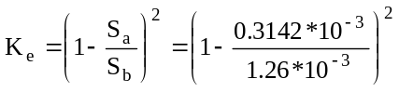=0.56345
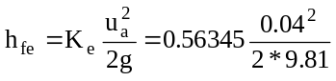=4.5949*10⁻⁵ m
h_{fe} = 0.01637*9.81 = 0.00045 J/kg

2.32. A pipe of 0.1m² area suddenly enlarges to 0.4m² area. The quantity of water flowing in the pipe is 0.3m³/s and the pressure at the smaller part of the pipe is 8.3*10⁵ N/m². Find out
i. head lost in m due to sudden expansion
ii. pressure in the larger part of the pipe
iii. power required in pumping the water through the enlargement
Data: Q = 0.3m³/s
S_{a} = 0.1m² | S_{b} = 0.4m²
We know Q=u_{a}S_{a} ⇒ u_{a}=Q/S_{a}
u_{a} = 0.3/0.1 = 3m/s
and u_{b} = 0.3/0.4 =0.75m/s
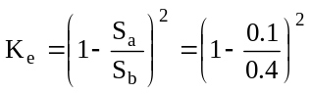=0.5625
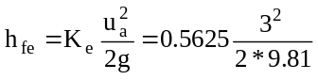=0.258m
h_{fe} = 0.258*9.81 = 2.531 J/kg
Applying Bernoulli’s equation between inlet and outlet
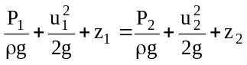, but z₁=z_{2,}
∴ the above equation reduces to
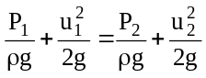
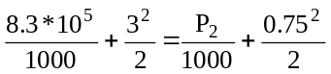
P₂=8.3422*10⁵
Power, P=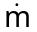*energy loss in J/kg
P = Q*ρ*h_{fe} = 0.3*1000*2.531=759.3W.

Free and wall turbulence
Turbulence can result either from contact of the flowing stream with solid boundaries or from contact between two layers of fluid moving at different velocities. The first kind of turbulence is called wall turbulence and the second kind of turbulence is called free turbulence. Wall turbulence appears when the fluid flows through closed or open channels or past solid shapes immersed in the stream. Free turbulence appears in the flow of a jet into a mass of stagnant fluid (or when a boundary layer separates from a solid wall and flows through the bulk of the fluid).
Flow in boundary layers:
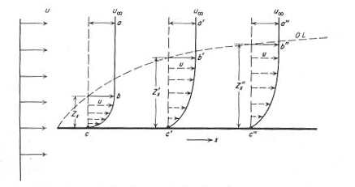
A boundary layer is defined as that part of a moving fluid in which the fluid motion is influenced by the presence of a solid boundary. As a specific example of boundary layer formation consider the flow of fluid parallel with a thin plate as shown in the figure 2.16.
Figure 2.16. Boundary layer formation on a thin plate.
The velocity of the fluid upstream from the leading edge of the plate is uniform across the entire fluid stream. The velocity of the fluid at the interface between the solid and the fluid is zero. The velocity increases with distance from the plate as shown in figure 2.16. Each of these curves corresponds to a definite value of x, the distance from the leading edge of the plate. The curves change slope rapidly near the plate. They also show that the local velocity approaches asymptotically the velocity of the bulk of the fluid stream.
The line OL represents an imaginary surface which separates the fluid stream into two parts. One in which the fluid velocity is constant and the other in which the velocity varies from zero at the wall to a velocity substantially equal to that of the undisturbed fluid. This imaginary surface separates the fluid that is directly affected by the plate from that in which the local velocity is constant and equal to the initial velocity of the approach fluid. The zone or layer between the line OL and the plate constitutes the boundary layer.
Laminar and turbulent flow in boundary layer
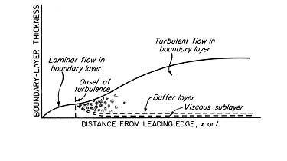
The fluid velocity at the solid interface is zero, and the velocities close to the solid surface are small. Flow in this part of the boundary layer very near the surface therefore is laminar. Further away from the surface the fluid velocities, though less than the velocity of the undisturbed fluid, may be fairly large, and flow in this part of the boundary layer may become turbulent. Between the zone of fully developed turbulence and the region of laminar flow is a transition, or buffer, layer of intermediate character. Thus a turbulent boundary layer is considered to consist of three zone; the viscous sub layer, the buffer layer and the turbulent zone. This is shown in figure 2.17.
Figure 2.17. Different region of boundary layers.

Boundary layer formation in straight circular tubes
Consider a straight tube having a bell shaped entrance as shown in figure 2.18. A boundary layer begins to form at the entrance of the tube, and as the fluid moves through the firs part of the channel, the layer thickens. During this stage the boundary layer occupies only part of the cross section of the tube, and the total stream consists of a case of fluid flowing in a rod like manner at constant velocity and an annular boundary layer between the wall and core. In the boundary layer the velocity increases from zero at the wall to the constant velocity existing in the core. As the stream moves further down the tube, the boundary layer occupies an increasing portion of the cross section. Finally at a point well down stream from the entrance, the boundary layer reaches the centre of the tube and rod like core disappears and the boundary layer occupies the entire cross section of the stream. At this point the velocity distribution in the tube reaches its final form, as shown in figure 2.18 (position d) and remains unchanged during the remaining length of the tube. Such flow with an unchanging velocity distribution is called Fully developed flow.
a
b
c
d
Figure 2.18. Boundary layer formation in a circular pipe
The length of the entrance region of the tube necessary for the boundary layer to reach the centre of the tube and for fully developed flow to be established is called the transition length. Since the velocity varies not only with length of the tube but with radial distance from the centre of the tube, flow in the entrance region is two dimensional. The approximate length of straight pipe necessary for completion of the final velocity distribution, for laminar flow is 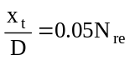, where x_{t} is transition length and D is diameter of pipe.
The transition length for turbulent flow is less than that for laminar flow unless the Reynolds number is small.

Boundary layer separation and wake formation
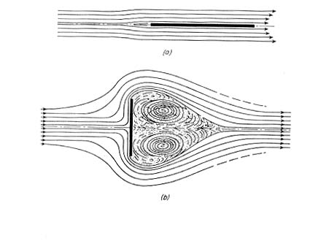
Consider the fluid flow over a flat plate. At the trailing edge of a plate which is parallel to the direction of flow, the boundary layers on the two sides of the plate have grown to a maximum thickness. For a time, after the fluid leave the plate, the layers and velocity gradient persist. Soon, however, the gradients fade out; the boundary layers intermingle and disappear, and the fluid once more move with a uniform velocity. This is shown in figure 2.19.a
Figure. 2.19. Flow past flat plate: (a) Flow parallel with plate (b) perpendicular to plate

Suppose, now the plate is turned at right angles to the direction of flow over the upstream face, then the fluid reaches the edge of the plate, its momentum prevents it from making the sharp turn around the edge and it separates from the plate and proceeds outward into the bulk of the fluid. Behind the plate is a back water zone of strongly decelerated fluid, in which large eddies, called vortices are formed. This zone is known as the wake. The eddies in the wake are kept in motion by the shear stresses between the wake and the separated current. They consume considerable mechanical energy and may lead to a large pressure loss in the fluid.

Prandtl mixing length theory for turbulent shear stress
In turbulent flow shear stress varies. Shear stress τ, depends on u’, v’, fluctuating component of velocity in the direction of x and y due to turbulence. So shear stress is given in terms of u’ v’ by the equation
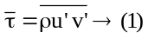
But it is very difficult to measure u’ v’. To overcome this difficulty Prandtl presented a mixing length hypothesis which can be used to express turbulent shear stress in terms of measurable quantities.
According to Prandtl, the mixing length ‘l’, is that distance between two layers in the transverse direction such that the lumps of fluid particles from one layer could reach the other layer and the particles are mixed in the other layer in such a way that the momentum of the particles in the direction of x is same. It is also assumed that the velocity fluctuation in the x-direction u’ is related to the mixing length ‘l’ as 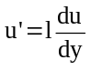and v’, the fluctuating component of velocity in y-direction is of the same order of magnitude as u’ and hence 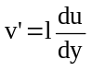.
Now, 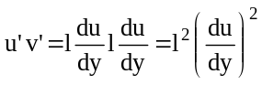,
Substituting the value of equation (1) gives,
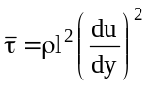
Thus the total shear stress at any point in turbulent flow is the sum of shear stress due to viscous shear and turbulent shear and can be written as
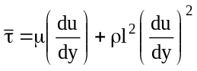

Exercise Problems

1. A 5 m long pipe is inclined at angle of 15° with the horizontal. The smaller section of the pipe, which is at a lower level is of 80 mm dia and the larger section of the pipe is 240 mm dia as shown in the figure. Determine the difference of the pressure between the two sections in N/m², if the pipe is uniformly tapered and the velocity of water at the smaller section is 1 m/s.

2. A pipeline carrying oil of specific gravity 0.87 changes in diameter from 200 mm dia at a position A to 500 mm at a position B which is 4 m at a higher level. If the pressure at A and B are 0.981X10⁵ N/m² respectively and the discharge is 200 liter/s. Determine the loss of head and direction of flow.

3. Water is pumped at constant rate of 150 liter/min from a large reservoir resting on the floor to the open top of the tower. The point of discharge is 7 m above the floor and the total frictional losses in 5 cm pipe line from the reservoir to the tower amounts to be 0.3 m. At what height in the reservoir must be the water layer to be kept if the pump can develop only 0.125 HP?

4. 0.7 X 10^{– 3} m3/s of acid is to be pumped through a 50 mm dia pipe and 30 m long to a 12 m higher than its reservoir. The frictional losses amounts to 3m and efficiency of the pump is 50%. Calculate (a) developed head and (b) power required to pump the acid. Density of acid is 1840 kg/m³.

5. An acid of specific gravity 1.53 is to be pumped at the rate of 4000cc/s through a lead pipe of 25mm diameter and raised to a height of 25m. The pipe includes two right angled bends and head losses due to this bends is estimated to be 45 times the velocity head. Calculate the power and HP required.

6. A pump requires an input of 7.5kw of power and has an efficiency of 0.85. It is used to lift oil of specific gravity 0.9 from a level sump to an overhead tank. The elevation of the oil levels in the sump and the overhead tank are respectively 580m and 596m above mean seal level. If the losses in the system are 1.5m of oil. Determine the discharge of oil to the over head tank.

7.If in the problem 6, the sump is closed and the oil there is under a pressure of 49.05Kpa, determine the discharge to the overhead tank.

8.A pump draws water from a sump and delivers to another tank at the rate of 80 lps. Suction and delivery pipes are respectively 250mm and 150mm. The delivery pipe take off is 500mm above the suction pipe take off. A differential manometer is connected to these two points and the deflection of mercury was observed to be 200mm. Calculate the power delivered by the pump.
9. A crude oil of viscosity 0.9P and specific gravity 0.8 is flowing through a horizontal circular pipe of diameter 8 cm and of length 15m. Calculate the difference of pressure at the two ends of the pipe, if 50kg of the oil is collected in a tank 15 seconds.
10. Determine (a) the pressure gradient, (b) the shear stress at the two horizontal parallel plates and (c) the discharge per meter width for the laminar flow of oil with a maximum velocity of 1.5m/s between two horizontal parallel fixed plates which are 8 cm apart. Viscosity = 1.962Ns/m².
11. Laminar flow of an oil (specific gravity = 0.9 and kinematic viscosity 2.5x10⁻⁴ m²/s ) occurs in a vertical pipe of 25 mm diameter. The pressure at one point in a pipe is 2x10⁵ N/m² and the pressure at another point 15 m below the above point is 4.5 x 10⁵ N/m² . Determine the direction and mass rate of oil flowing. Calculate the Reynolds number for the flow conditions.

12. Calculate the friction factor when water is flowing under laminar conditions in a pipe of 1 cm diameter and at a velocity of 10cm/s

13. Benzene at 25ºC is flowing through a 10m length of tubing 2.5 mm inside diameter. The pressure drop is known to be 3 cm of mercury. What is the mass flow rate of benzene. Density and absolute viscosity of benzene at 25ºC are 0.87g/cc and 0.6cP respectively.

14. During a test on 31.6 cm diameter pipe, the flow rate is 135 liter/s and the velocity distribution is given by u=c₁ + c₂ r² where you is velocity at any radius ‘r’ from the centre and c₁ and c₂ are constants. Determine the constants c₁ and c₂ specifying their units. At what radius is the actual fluid velocity equal to the mean fluid velocity.

15. Water is flowing in a smooth 20 cm i.d pipe. Determine at what point the velocity is equal to the average velocity and at what point is equal to the maximum velocity if Reynolds number is 1750.
Examination questions and problems
Feb 1995
1. | a. What is the principle employed in Bernoulli’s theorem?
 | b. Derive the Bernoulli’s equation. State the assumptions and apply correction factors.
 | c. Oil of specific gravity 0.75 is pumped from a tank over a hill through a 60cm diameter pipe with a pressure at the top of the hill maintained at 175kN/m². The summit is 80m, above the oil surface in the tank and oil is pumped at the rate of 0.06m³/s. If the head lost due to friction in pipe line is 5m, what HP must the pump supply to the liquid?
2. | a. Starting from the velocity distribution equation for laminar flow, show that the maximum velocity in a pipe is twice the average velocity
 | b. Water flows at a rate of 6 m³/hr through a sudden enlargement from a 25mm to a 40mm diameter pipe. Calculate the loss in head. Derive the equation used here.

Aug 1995
3. | a. State and prove Bernoulli’s theorem.
 | b. What are the correction factors applied to the above theorem.
 | c. Explain continuity equation.
4. | a. Derive an expression for velocity distribution in laminar flow through a circular pipe.
 | b. Calculate the head lost when water flowing through a 4cm diameter pipe at the rate of 0.75lit/min is suddenly sent to a pipe of 8cm diameter.
 | c. A fluid of constant density flows at the rate of 15lit/s in a long pipe of 100mm diameter (AB). The pipe branches into BC, BD each of 25mm diameter and a third pipe BE 50mm diameter. The flow rates are such that the flow through BC is 3 times the flow rate through BE and the velocity through BD is 4m/s. Determine the velocities in pipes AB, BC and BE.

Feb 1997
5. | a. What is Reyonld’s experiment?
 | b. Mention the finding of above experiment.
 | c. Prove the velocity distribution for viscous flow in a smooth circular pipe is parabolic in nature. Prove also that the maximum velocity in such a case is two times the average velocity.
6. | a. Write the different forms of Bernoulli’s equation
 | b. A fire fighting truck is sucking water from a river and delivering it through a nozzle at 30m above the suction point. The suction point and delivery point are connected with a long hose of diameter 100m. What is the power required to delivery at the rate of 2500lit/min of water.

Aug 1997
7. | a. State Bernoulli’s equation in differential form without taking into consideration the losses due to friction. (3)
 | b. Why correction factor are used in above equations? Evaluate kinetic energy correction factor. (6)
 | c. Brine of specific gravity 1.15 is draining from the bottom of a large open tank through 50mm pipe. The drain pipe ends at 5m below the surface of brine in the tank. Calculate the velocity of flow at the point of discharge. (9)
 | d. Write the assumptions used in the solution of above problem. (2)
8. | a. State Hagen-Poiseullie’s equation for the flow of fluids through a circular pipe.
b. Water is flowing through a circular pipe of 10cm internal diameter at 30ºC. The flow is turbulent. The velocity at the centre of pipe is found to be 0.1m/s.
    - Calculate shear stress at wall.
    - Calculate the eddy diffusivity at r/r_{w} =0.5, where r_{w} is the radius of duct.
Properties of water at 30ºC and 1 atm are ρ=995.7kg/m³ and μ=801.5*10⁻⁶Ns/m².

Mar 1998
9. | a. State and derive Bernoulli’s equation incorporating the correction for kinetic energy of stream and fluid friction. (12)
 | b. Water is flowing through a pipe having diameter 30cm and 20cm at the bottom and upper end respectively. The intensities of pressure at the bottom and upper end are 2.5 and 1 kgf/cm² respectively. Determine the difference in datum head if the rate of flow through the pipe is 40lit/s. (8)
10 | a. Prove that for a Newtonian fluid passing through a pipe of radius r, the average velocity is precisely one half the maximum velocity.
 | b. Water is flowing in a smooth 20cm ID pipe. Determine at what point the velocity is equal to the average velocity and at what point is equal to the maximum velocity if Reynolds no. is 1750.
 | c. Define hydraulic radius and equivalent diameter. What is equivalent diameter for a rectangular duct, an annulus and a triangular duct.

Sept 1998
11 | Water from a tank is to be pumped through a pipe of 250mm diameter to a tank at an elevation of 20m above the water level at a rate of 30kg/s. What pressure must the pump develop? What is the power need to pump if the efficiency of the pump is 60%? Assume frictional losses in the entire piping system are 1.5J/kg.
12 | An oil of viscosity 0.1Ns/m² and relative density 0.9 is flowing through a circular pipe of diameter 5cm and of length 300m. The rate of flow of fluid through the pipe in a length of 300m and also the shear stress at the pipe wall.

Aug 2000
13. | a. Derive Bernoulli’s equation. State the assumptions made. (10)
 | b. Oil of specific gravity 0.75 is pumped from a tank over a hill through a 60cm diameter pipe with a pressure at the top of the hill maintained at 175kN/m². The summit is 80m, above the oil surface in the tank and oil is pumped at the rate of 0.06m³/s. If the head lost due to friction in pipe line is 5m, what HP must the pump supply to the liquid? (10)
14. | Derive the expression for the velocity distribution in a pipe line for laminar flow and show that the maximum velocity is twice the average velocity. (20)
15. | Express equation of continuity, Bernoulli’s equation and ideal gas law n the differential form. (6)

Mar 2001
16. | a. State Bernoulli’s equation in point form and also write different forms of the same. (2+6)
 | b. A pump draws solution of specific gravity 1.84 from a storage tank through a 75mm pipe. The efficiency of pump is 60%. The velocity in the suction line is 1m/s. The pump discharges through a 50mm pipe to an overhead tank. The end of discharge pipe is 15m above the level of solution in the feed tank. The friction losses in the entire system are 30J/kg. What pressure must the pump develop? What is the horsepower of the pump? (12)
17. | a. Derive the relation between friction factor and pressure drop for an incompressible fluid through a pipe, starting from fundamentals. (12)
 | b. Show that for laminar flow of a fluid the relationship between f and N_{Re}is f = 16/N_{Re}. (8)

Aug 2001
18. | a. State and explain the continuity equation. (4)
 | b. Derive the Bernoulli’s equation. Explain the assumptions made in deriving the Bernoulli’s equation. (8)
c. Find the drop in pressure due to friction in a 60m long and 25mm diameter pipe, when water is flowing at the rate of 3kg/s. If the pressure drop falls by one half, what will be the new flow rate?
Data : Density of water = 1000 kg/m³
Viscosity of water = 0.008 poise. (8)
19. | Determine the cost of pumping 300000 lit/hr of an oil having specific gravity of 0.90 and viscosity 30cp through a pipeline 25 cm diameter and 50km long. It may be assumed that the efficiency of the pump together will motor is 50% and the power costs Rs.1.4 per kWh. The pipe line is horizontal and 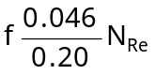? (14)

Model question paper – 1
20. | a. Derive the velocity distribution equation for laminar flow. Show that the maximum velocity in a pipe is twice the average velocity. (15)
 | b. A compound pipe line 1650 m long is made up of pipes 45 cm for 900m, 375 cm diameter for 450m and 30cm for 300m is required to be replaced by a pipe of uniform diameter. Find the equivalent size of the pipe. (5)
21. | a. Derive the Bernoulli’s equation. State the assumptions made. (10)
 | b. Water at 25ºC is pumped at a constant rate of 24*10⁻⁴m³/s from a large reservoir resting on the floor to the open top of an experimental absorption tower. The point of discharge is 5m above the floor and the friction loss in the 0.05m pipe from the reservoir to the tower is 2.4J/kg. At what height must the height of water in the reservoir be kept such that the pump can develop only 100W. (10)

Model question paper – 2
22. | a. Derive Hagen-Poiseuilles equation and indicate any two typical applications of the equation.
 | b. A liquid of density 1000kg/m³ flow in steady state in cylindrical pipe of 0.05m ID at 7.2m³/hr. Calculate the head loss and the pressure drop for a sudden expansion to a pipe of 0.1m ID.
23. | a. Derive the Euler’s equation of motion for steady flow along a stream line. Obtain therefrom, Bernoulli’s equation for an incompressible fluid flow.
 | b. A pipeline carrying oil of specific gravity 0.87, changes in diameter from 30cm diameter at a position A to 60cm diameter at a position B which is 3m at a higher level. If the pressure at A and B are 98.1 and 58.86 kN/m² respectively and the discharge is 0.5m³/s, determine the loss of head and direction of flow.

Aug 2002
24. | a. Define :  i. Unit Operations ii. Unit processes  iii. Newtonian fluids iv. Laminar flow  v. Turbulent flow vi. Reynolds number  vii. Fully developed flow (7*2=14 Marks)
25. | b. Water is flowing through a tapered pipe having diameters 20cm and 10 cm, at the larger and smaller ends, respectively. Determine the velocity head and the rate of discharge in liters/sec at the smaller end, if velocity of water at larger end is 3m/s. (8 )
26. | a. Derive Bernoulli's equation and state the assumptions made.(10)
 | b. Show that for laminar flow through a pipe, the maximum velocity in a pipe is twice the average velocity. (10)

